Optimum design of pendulum tuned
mass dampers for applications to high- rise buildings subjected to wind-induced vibrations

Jimi HENDRIX

Academic year
2019 – 2020
Research Methods in Civil Engineering report under the supervision of
Prof. Arnaud DERAEMAEKER

the co-supervision of
Dr. Cédric DUMOULIN

this is the abstract

1 Introduction

1.1 Context

2 State-of-the-art

TMDs have first been optimized in [1]. A TMD is represented in Figure 2.1.

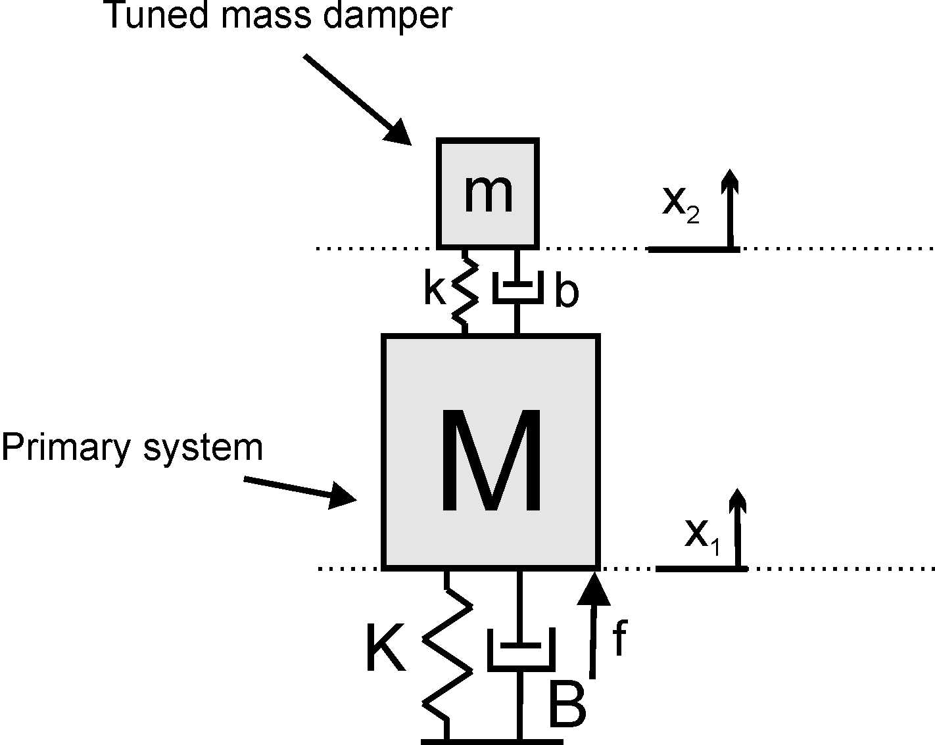

Figure 2.1 – Tuned mass damper attached to a primary system

3 Workplan

This is the work plan

4 Tentative schedule

This is the tentative schedule

Bibliography

[1] JP Den Hartog. Mechanical vibrations. McGraw-Hill Book Company. 1956.

